To all Members of the Ripponden Parish Council Environment Committee

You are hereby summoned to attend an Environment Committee Meeting to be held at Ryburn United Football Club on Tuesday 26th September 2023 at 7.15pm for the purpose of transacting the following business.

- To accept apologies for absence and lateness.
- To approve the minutes of the meeting held on 25th July 2023.
- To review and accept the Terms of Reference of the Environment Committee.
- To review the Environment budget for 23/24.
- To discuss matters arising from the previous meeting.
  - To discuss the Ripponden War Memorial railings and the maintenance of the garden.
  - To discuss the damage to and repair of the K6 telephone box on Rochdale Road
  - To discuss the lack of play equipment for older children in the Rishworth play area and Henry Whiteley Park.
  - To discuss replanting of the War Memorials.
- To hear reports from councillors and co-opted members.
- To discuss the painting of Pretoria Bridge and the maintenance of the footpath leading to it.
- To discuss the maintenance of Parish parks in general.
- To discuss the potential relocation of the stone sculptures.
- To discuss the Rishworth turning circle.
- To agree a date for the next meeting

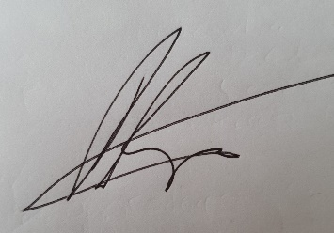

Peter Hunt
Chair of Environment Committee

