

To all members of the Ripponden Parish Council:-

You are hereby summoned to attend the 1236th Meeting of the Ripponden Parish Council to be held at Ryburn United Football Club Ripponden on Thursday 10th August 2023 at 7.15pm for the purpose of transacting the following business.
AGENDA

- Reminder by the Chairman of the expectations for audio or visual recording of the meeting.

- To receive apologies for absence and lateness
Cllrs are reminded of the need to tender apologies to the Acting Clerk with the reason if they are unable to attend.

- Public Participation
An opportunity for members of the public to address the Parish Council on any issues concerning them about the Parish

- To accept the minutes of the 1235th Meeting held on Thursday 27th July 2023

- To receive Parish Councillors’ declarations of interest

- To receive information on any on–going items identified in these and previous Minutes and decide further action where necessary

6.1 To consider and discuss HR matters
6.2 To consider any updates regarding premises for use as a storage facility and office for the Parish Council

- To receive reports from the Acting Clerk, Chairman, Committees, Councillors and Outside Bodies by Council Representatives

- To receive reports from Calderdale Councillors who represent Ryburn Ward

- To agree Accounts for payment and note payments made

- To receive Correspondence

i. Items received after the Agenda went out
ii. Information only
iii. Invitations

11. To discuss the Parish Council setting up an online Sage payroll system for the payment of employees

12. To discuss the payment of Parish Council accounts

13. To discuss Cllr Greenwood looking into the viability of Scribe Accounts software for Parish & Town Councils

14. To discuss a Grant Application from Ripponden Business Network

15. To discuss a Grant Application from the Young at Heart Club

16. To discuss parking charges at Royd Lane car park

17. To discuss Planning Applications, to receive Planning Decisions and to discuss Planning and Enforcement
issues

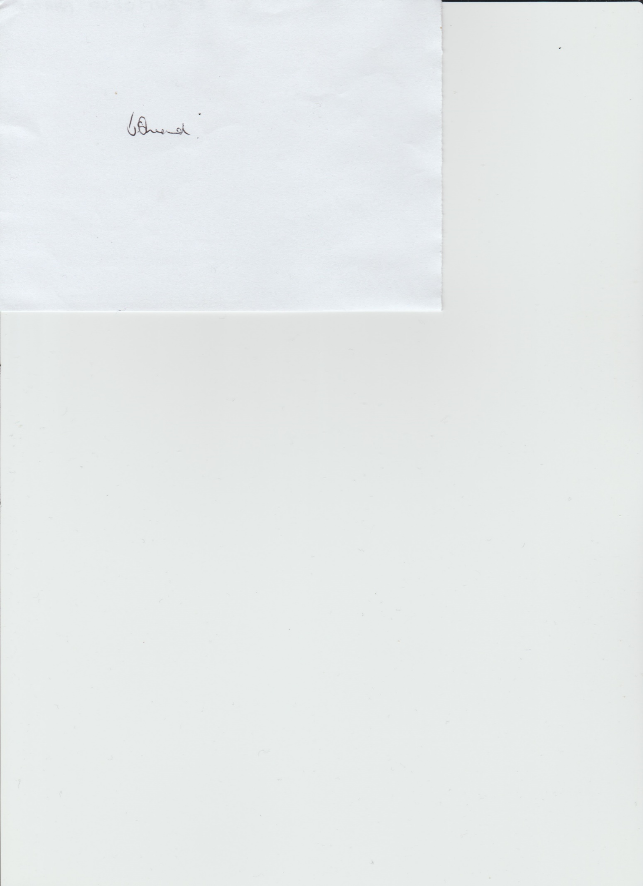

Janet Sheard
Acting Clerk Dated 3rd August 2023

Tel: 0791 8693 383

