

To all members of the Ripponden Parish Council

You are hereby summoned to attend the 1237th Meeting of the Ripponden Parish Council to be held at Ryburn United Football Club Ripponden on Thursday 24th August 2023 at 7.15pm for the purpose of transacting the following business.
AGENDA

- Reminder by the Chairman of the expectations for audio or visual recording of the meeting.

- To receive apologies for absence and lateness
Cllrs are reminded of the need to tender apologies to the Acting Clerk with the reason if they are unable to attend.

- Public Participation
An opportunity for members of the public to address the Parish Council on any issues concerning them about the Parish

- To accept the minutes of the 1236th Meeting held on Thursday 10th August 2023

- To receive Parish Councillors’ declarations of interest

- To receive information on any on–going items identified in these and previous Minutes and decide further action where necessary

- To receive reports from the Acting Clerk, Chairman, Committees, Councillors and Outside Bodies by Council Representatives

- To receive reports from Calderdale Councillors who represent Ryburn Ward

- To agree Accounts for payment and note payments made

- To receive Correspondence

i. Items received after the Agenda went out
ii. Information only
iii. Invitations

11. To consider any updates regarding premises for use as a storage facility and office for the Parish Council

12. To discuss the Parish Council setting up an online Sage payroll system for the payment of employees

13. To discuss HR Matters

14. To discuss and sign off the bank reconciliation

15. To discuss the payment of Parish Council accounts including payments to HMRC

16. To discuss parking charges at Royd Lane car park

17. To discuss the Grant Application from Ripponden Business Network

18. To discuss weeds and overhanging greenery

19. To discuss recruitment of a Clerk & Responsible Finance Officer

20. To discuss the Parish Christmas Lights

21. To discuss Public Participation at Council Meetings

22. To discuss the security of the eagle sculpture

23. To discuss Planning Applications, to receive Planning Decisions and to discuss Planning and Enforcement
issues

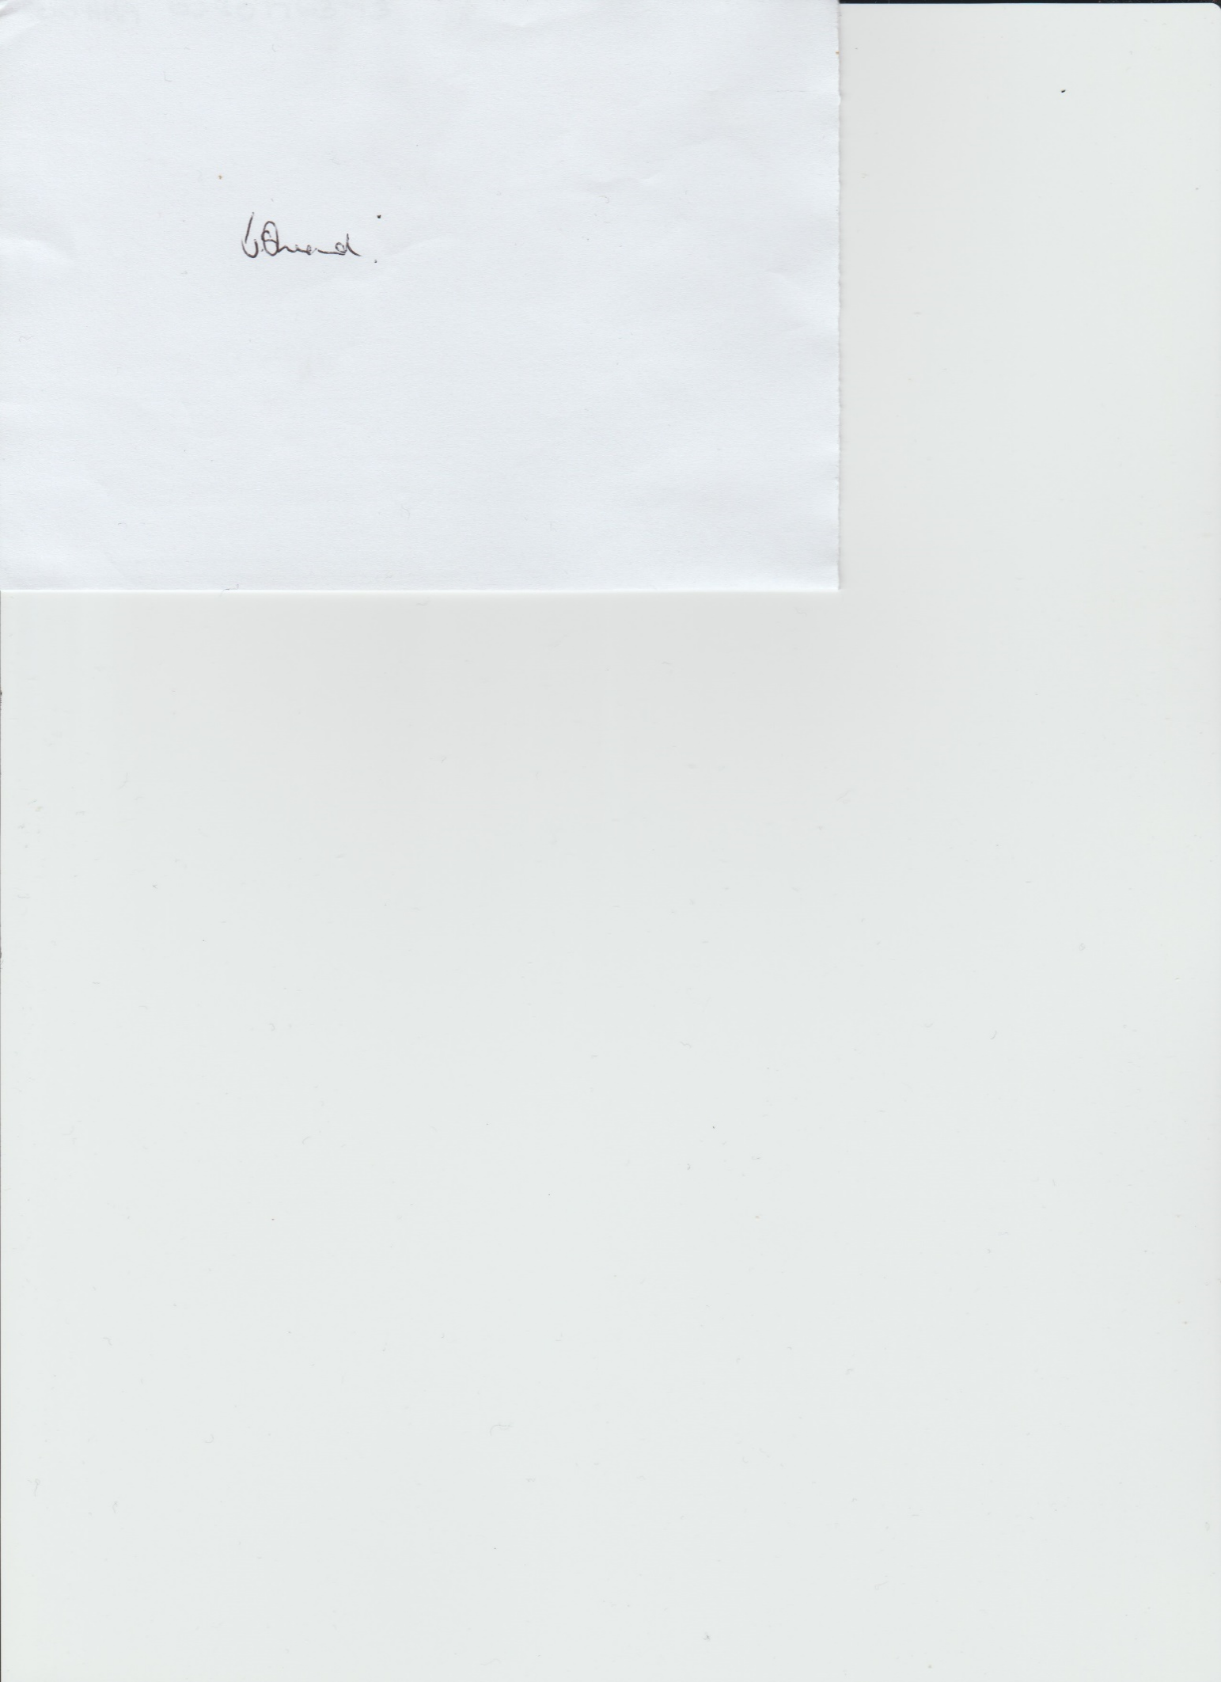

Janet Sheard
Acting Clerk Dated 18th August 2023

Tel: 0791 8693 383

