To all Members of the Ripponden Parish Council Standards Committee

You are hereby summoned to attend the Standards Committee Meeting which will be held at Ryburn United Football Club on 19th March at 7.15pm for the purpose of transacting the following business.

- To accept apologies for absence and lateness.
- To discuss matters arising from the previous meeting.
- To review the Privacy Notice and recommend any changes to Full Council.
- To discuss, amend and recommend any changes to the Grants Policy and criteria to Full Council.
- To review the Complaints Procedure and recommend any changes to Full Council.
- Updates from committee members.
- Date of next meeting.
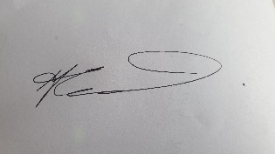

Cllr Alex Greenwood
Chair of Standards

